# **How to run Collections remotely in Postman?**

***Last Updated On***

[**HOME**](https://qaautomation.expert/)

You can share your collections, collection folders, APIs, and environments with collaborators. There are several different ways to share an element. Here, we are using API to share the Postman Collection.

To share a collection’s JSON using the Postman API, do the following:

***Step 1*** – Go to your ***collection***– Click the ***arrow***– Click on the ***Share***button.

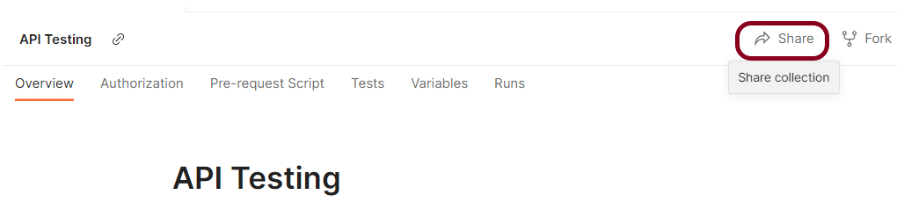

***Step 2*** – Select ***“Via API”.***

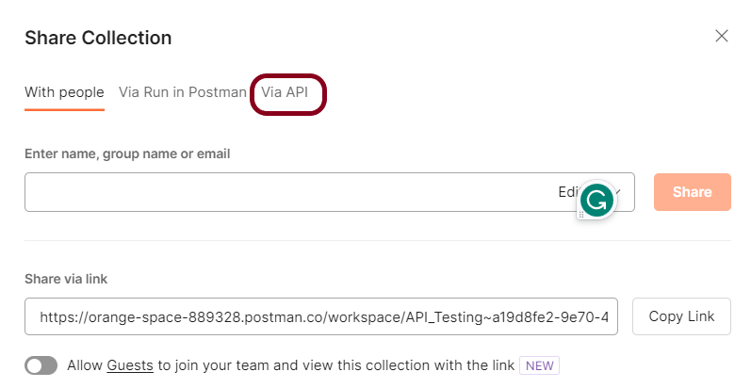

***Step 3*** – Select ***Get collection JSON using Collection Access Key***

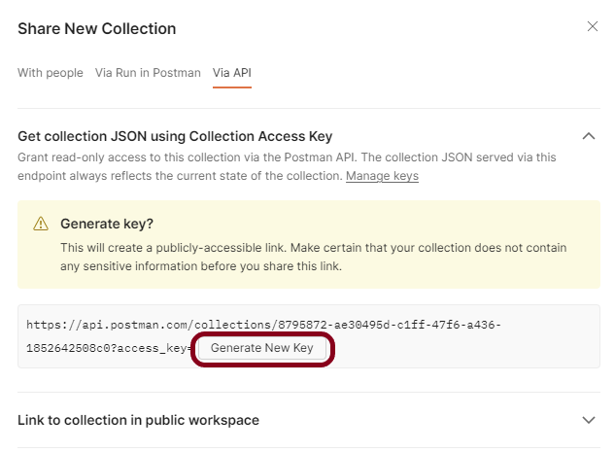

Advertisement

***Step 4*** – Select ***Generate New Key*** to create a read-only collection access key. This key expires after 60 days of inactivity.

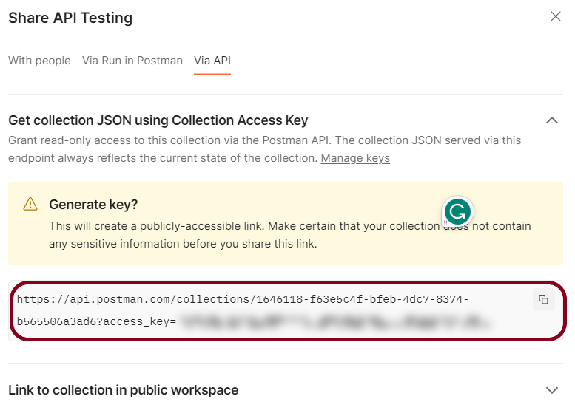

***Step 5*** – ***Copy the link***and go to the Command line. Here we can run the collection using the collection URL using our Newman tool. Newman is the command-line runner for the postman.

Run the collection through URL by running the command:

|  |  |
| --- | --- |
| 1 | newman run <copied URL> |

***Note: If Newman is not installed, please refer to this tutorial.***

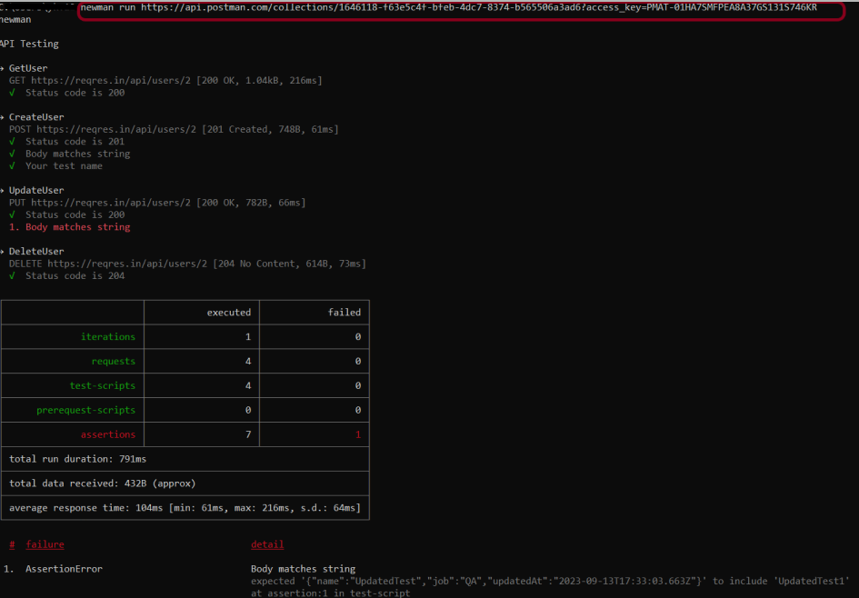

It starts running the Collection and displays the result. The same command is used to run the collection in the Remote system, even if that system has no Postman app installed.